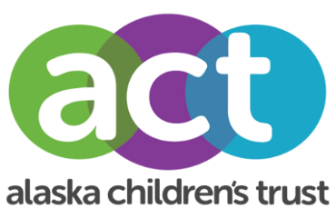

Media Advisory

EMBARGOED INFORMATION until Tuesday, December 8
Contact: Thomas Azzarella, 907-602-0569
tazzarella@alaskachildrenstrust.org

Alaska Afterschool Programing is a New Top 10 State for Afterschool, Ranking

4th Nationwide

ANCHORAGE, Alaska — The America After 3pm survey ranks afterschool programs across the nation using indicators like afterschool program participation, programs reaching children in need, and parent’s satisfaction with key features of their child’s afterschool care. For the first time, Alaska breached the top ten nationwide, coming in at 4th. This marks a huge jump from a ranking of 46th in 2009 and shows steady progress from a ranking of 31st in 2014.

In addition to ranking 4th, Alaska also excelled in areas like variety of programming, 97% of parents are satisfied with their child’s afterschool program, and Alaska ranked 1st in the nation for parental satisfaction for variety of activities offered. Alaska’s children are building life skills, doing physical activities, building social skills, and engaging in STEM and computer science opportunities in high numbers at afterschool programs across the state.

While Alaska excelled in many areas, there is still room for growth. For every child in an afterschool program there are 3 waiting for a spot. Barriers to programs include cost and space availability. Thomas Azzarella, Director of the Alaska Afterschool Network says, “We are determined to continue the progress to make afterschool programs available to all children and youth here in Alaska.”

WHAT: Alaska afterschool ranking data and survey results

WHERE: Visit the America After 3pm Alaska page aa3pm.co/Alaska

###

About the Alaska Afterschool Network
The Alaska Afterschool Network is a statewide network with the mission support, strengthen, and advocate for quality afterschool programs and activities for children, youth, and families.

About Alaska Children’s Trust
Alaska Children’s Trust (ACT) is the statewide lead organization focused on the prevention of child abuse and neglect. For over thirty years, we have invested resources across Alaska to ensure children live in safe, stable, and nurturing environments.

